
Department of Computer Science

Lab Manual

of

MACHINE LEARNING

MCA521-4

Class Name: IV MCA

Master of Computer Application

2026

Prepared by: Verified by:
Dr. Rupali Sunil Wagh
Dr. Helen K Joy
Dr. Shivangi Singh

Jai Pareek
2547228
4 MCA B

Department Overview
Department of Computer Science of CHRIST (Deemed to be University) strives to shape outstanding computer professionals with ethical and human values to reshape nation’s destiny. The training imparted aims to prepare young minds for the challenging opportunities in the IT industry with a global awareness rooted in the Indian soil, nourished and supported by experts in the field.

Vision
The Department of Computer Science endeavours to imbibe the vision of the University “Excellence and Service”. The department is committed to this philosophy which pervades every aspect and functioning of the department.

Mission
“To develop IT professionals with ethical and human values”. To accomplish our mission, the department encourages students to apply their acquired knowledge and skills towards professional achievements in their career. The department also moulds the students to be socially responsible and ethically sound.

Introduction to the Programme
Master of Computer Applications (MCA) is a post-graduate programme of CHRIST (Deemed to be University) and approved by the All India Council of Technical Education (AICTE). It is a two-year programme spread over six trimesters to bridge the chasm between computer studies and applications, bringing within reach of enthusiastic youngsters an excellent group of experienced and dedicated staff and experts, and an enviable infrastructure. MCA at CHRIST (Deemed to be University) strives to shape outstanding computer professionals with ethical and human values to reshape the nation’s destiny. The training programme aims to prepare young minds for challenging opportunities in the IT industry with a global awareness rooted in the Indian soil, nourished and supported by experts in the field. The Department is committed to the motto “Excellence and Service,” and this philosophy pervades every aspect of its functioning.

Programme Objective
This programme is conceptualised and designed based on the strong commitment of the
department to provide better quality education to the students. The principal objectives of this
course are to:
● Heighten technological awareness
● Train future industry specialists
● Encourage effective software development
● Provide research training
● Involve students in innovative research
● Produce graduates with a two-year professional education in Computer Science with
technical, professional, and communications skills.

Ethics and Human Values
1. Only proprietary or open-source software would be used for academic teaching and
learning purposes.
2. Copying of programs from the internet, friends or from other sources is strictly
discouraged since it impairs development of programming skills.
3. Unique Practical (Domain based) exercises ensure that the students don’t get involved in
code plagiarism.
4. Projects undertaken by students during the course are done in teams to improve
collaborative work and synergy between team members.
5. Projects involve modularization which initiates students to take individual responsibility
for common goals.
6. Passion for excellence is promoted among the students, be it in software development or
project documentation.
7. Giving due credit to sources during the seminar and research assignment is promoted
among the students
8. The course and its design enforce the practice of good referencing technique to improve
the sense of integrity.
9. Courses involving group discussions and debates on ethical practices and human values
are designed to sensitize the students in dealing with customers and members within the
Organization.

Programme Outcomes:
P01: Foundation Knowledge: Apply knowledge of mathematics, programming logic, and
coding fundamentals for solution architecture and problem-solving.
P02: Problem Analysis: Identify, review, formulate, and analyse problems primarily focussing on customer requirements using critical thinking frameworks.
P03: Development of Solutions: Design, develop and investigate problems with as an
innovative approach for solutions incorporating ESG/SDG goals.
PO4: Modern Tool Usage: Select, adapt, and apply modern computational tools such as the
development of algorithms with an understanding of the limitations including human biases.
P05: Individual and Teamwork: Function and communicate effectively as an individual or a
team leader in diverse and multidisciplinary groups. Use methodologies such as agile.
P06: Project Management and Finance: Use the principles of project management such as
scheduling, and work breakdown structure and be conversant with the principles of Finance for profitable project management.
P07: Ethics: Commit to professional ethics in managing software projects with financial aspects.
Learn to use new technologies for cyber security and insulate customers from malware
P08: Life-long learning: Change management skills and the ability to learn, keep up with
contemporary technologies and ways of working.

Programme Educational Objectives(PEO’s)
PEO1: Develop innovative and effective software solutions through research that addresses
real-world challenges, grounded in a commitment to continuous learning and adaptability.
PEO2: Advance the knowledge and practices in the field of computer applications through
lifelong learning and rigorous research, supporting professional growth and academic excellence.
PEO3: Exhibit ethical leadership, social responsibility to contribute and enhance community
well-being by innovating solutions.
MCA521-4 – MACHINE LEARNING
Course Name: MACHINE LEARNING Code: MCA521-4
Total Hours: 75
L + P + T: 3 + 4 + 0
Max Marks: 100
Credits: 4
Course Type: Core Course
Course Category: Theo&Prac
Course Description
Machine Learning is a key area in computer applications that focuses on building models capable of making predictions or informed decisions based on data. A strong understanding of machine learning enables students to analyze and interpret complex datasets, develop predictive models, and extract meaningful insights. This course covers a wide range of machine learning concepts and techniques, including supervised and unsupervised learning. It provides a solid theoretical foundation while emphasizing practical, hands-on experience with algorithms and real-world data. The course equips students with the knowledge and skills required to apply machine learning techniques across various domains using modern tools and methodologies.
Course Objectives
This course enables students to understand the fundamental concepts of Machine Learning, including its core principles, terminology, and methodologies. Students will learn to differentiate between various types of learning algorithms such as supervised, unsupervised, and reinforcement learning, and recognize their appropriate applications.
Course Outcomes
After successful completion of the course, students will be able to:
● Explain the fundamental principles and scope of Machine Learning
● Implement modelling practices in machine learning for better generalisation
● Interpret predictive modelling results and performance of supervised machine learning techniques
● Assess the outcomes and effects of unsupervised machine learning processes
● Deploy robust machine learning models for interdisciplinary applications

Unit-1: INTRODUCTION TO MACHINE LEARNING Teaching Hours: 15 Hours
Introduction to AI – Knowledge Representation – Data – Representation of Data, Data Processing, Data Storage, Data Processing, Types of Data – Exploratory Data Analysis, Visualisations and Interpretation, Outliers
Machine Learning: Definition, Objectives, Components, Features, Applications – Traditional Programming v/s Machine Learning, Types of Machine Learning – Predictive Models, Statistical Inferences – Applications of Machine Learning
Challenges in ML: Insufficient Quantity of Data, Non-representative and Poor-Quality Data, Irrelevant Features, Estimation Estimation, Reducing Human Biases in Model Building, Ethical Use of Technology
Lab Exercises:
1. Data Preprocessing and visualisation
2. Data exploration and inferences

Unit-2: PROCESSES IN MACHINE LEARNING Teaching Hours: 15 Hours
Data Preparation and Model Selection: Effect of Data Preparation: Encoding, Nominal and Ordinal Representation, Feature Transformation and Feature Engineering, Generalisation, Normalisation, Sampling, Using Saved Weights, Model Selection Strategies: Overfitting, Underfitting, Bias-Variance Trade-off, Testing and Validation: Performance measures - Confusion matrix, Precision-Recall Trade off, F1 Score, ROC Curve, AUC, Error Analysis, Model Parameters, Hyperparameters, Hyperparameter Tuning, Cross Validation, Decision Functions: Introduction to Supervised Machine Learning Methods, Decision Functions, Decision Thresholds, Distance Measures, Hyperplanes, Regression & Classification Problems, Loss and Cost Functions, Linear Regression using OLS, Multi-class vs Multi-label, KNN Classification
Lab Exercises:
3. Saving weights of a generalised model.
4. Regression and Classification Evaluation Metrics: Illustration through Linear Regression and KNN Classification

Unit-3: SUPERVISED LEARNING ALGORITHMS Teaching Hours: 15 Hours
Learning through Optimisation: Gradient Descent, Linear Regression, Logistic Regression Computational Learning: Decision Trees, Naive-bayes classification, Support Vector Machines, Ensemble Learners: Learning, Voting, Bagging, Stacking, Boosting, Random Forests, GridSearchCV
Lab Exercises:

5. Regression through Gradient Descent
6. Comparison of Different Classifiers
7. Illustration of Ensemble Learning Methods

Unit-4: UNSUPERVISED LEARNING AND DIMENSIONALITY REDUCTION Teaching Hours: 15 Hours
Introduction: Types of Unsupervised Learning, Challenges in Unsupervised Learning, Concept of Cost Functions in Unsupervised Learning, Clustering Methods: Distance based, Centroid Based, Elbow method to find Optimal Number of Clusters, Silhouette Method, K-Means Clustering, Hierarchical Clustering: Agglomerative and Bottom Up, Applying Supervised Learning after Clustering, Dimensionality Reduction Methods: Principal Component Analysis (PCA), Linear Discriminant Analysis (LDA)
Lab Exercises:
8. KMeans and Elbow Methods
9. Hierarchical Clustering and Dendrograms
10. Dimensionality Reduction
11. Image Compression using Dimensionality Reduction.

Unit-5 Teaching Hours: 15 Hours
MACHINE LEARNING IN REAL-WORLD
Emerging Techniques: Role of ML in attaining Sustainable Development Goals, Time Series Preprocessing, Blackbox Methods: Neural Networks & Deep Learning, Reinforcement Learning/QLearning, Self Supervised Learning, Quantum Machine Learning, Keras and Tensorflow for designing Multi Layer Perceptron. Case Studies: CNN, RNN, Advances in Deep Learning, Natural Language Processing, Real Time Systems, Computer Vision, Robotics, Expert Systems, Generative Networks, Large Language Models. Model Deployment: Model Deployment: Connecting Models to User Interface, Deployment of ML Models.
Lab Exercises:
12. Training a Multi-layer perceptron
13. Deploying Trained ML-models

Text and Reference Books
[1] Campesato, O. (2020). Artificial Intelligence, Machine Learning and Deep Learning. Mercury Learning and Information.
[2] Andreas C. Müller and Sarah Guido (2017), “Introduction to Machine Learning with Python A Guide For Data Scientists” O’Reilly book
[3] Ethem Alpaydin (2005), “Introduction to Machine Learning”, Prentice Hall of India
[4] Max Kuhn and Kjell Johnson (2018), “Applied Predictive Modelling”, Springer

Essential Reading
[1] Stuart Russell and Peter Norvig(2020), “Artificial Intelligence: A Modern Approach” (4th Edition), Pearson
[2] Aurelien Geron(2019), “Hands on Machine Learning with Scikit-learn, Keras and Tensorflow”, 2nd Edition, O’Reilly Books
[3] Kevin P. Murphy(2012), “Machine Learning: A Probabilistic Perspective”, MIT Press
[4] Hastie, Tibshirani, Friedman(2008), “The Elements of Statistical Learning” (2nd ed), Springer
[5] Ian Goodfellow, Aaron Courville, Yoshua Bengio (2019), “Deep Learning (Adaptive Computation And Machine Learning Series)”, MIT Press
Additional Information (Web Resources):
1. Andrew Ng, Deeplearning.ai, Machine Learning Specialisation, offered through Coursera: https://www.deeplearning.ai/courses/machine-learning-specialization/

Evaluation Pattern: CIA - 50% ESE - 50%

LIST OF PROGRAMS

MSCAIML
Sl.no | Title of lab Experiment | Page number | RBT | CO
1 |  |  | L3 | CO1,3
2 |  |  | L3 | CO2,3
3 |  |  | L3 | CO3
4 |  |  | L3 | CO3
5 |  |  | L3 | CO3
6 |  |  | L3 | CO3,4
7 |  |  | L4 | CO3
8 |  |  | L3 | CO3
9 |  |  | L3 | CO4
10 |  |  | L5 | CO4

Evaluation Rubrics:
Evaluation Rubrics for each program would be

Submission Guidelines:
- Make a copy of the lab manual template with your <name_reg:no_subject name >,

- Copy the given question and the answer (lab code) with results, followed by the conclusion of that lab. Title the lab as lab number.
- Keep updating your lab manual and show the lab manual of that particular lab for evaluation.
- Create a Git Repository in your profile <ML lab-reg no> . Follow a different branch for each lab <Lab 1, Lab 2…>, and push the code to Git. The link should be provided in Google Classroom along with the PDF of the lab manual.
- Upload the PDF to Google Classroom before the deadline.

Lab 1

Lab Exercise I:

Aim

Evaluation Rubrics

Submission Guidelines
- Make a copy of the lab manual template with your <name_reg:no_subject name>
- Copy the given question and the answer (lab code) with results, followed by the conclusion of that lab. Title the lab as Lab 1.
- Keep updating your lab manual and show the lab manual of that particular lab for evaluation.
- Create a Git repository in your profile <ML lab-reg no>. Follow a different branch for each lab <Lab 1, Lab 2 …> and push the code to Git.
- Provide the Git link in Google Classroom along with the PDF of the lab manual.
- Upload the PDF to Google Classroom before the deadline.

Code with Results
Task 1:
Code:
import pandas as pd

aqi = pd.read_csv("/content/city_day.csv")
crop = pd.read_csv("/content/crop_production.csv")
print(aqi.shape)
print(aqi.info())
print(aqi.describe())
print(crop.shape)
print(crop.info())
print(crop.describe())
print(aqi.isnull().sum())
print(crop.isnull().sum())
print(aqi.duplicated().sum())
print(crop.duplicated().sum())
Conclusion /inference
Number of Rows: 29,531
Number of Columns: 16
Duplicate Records: 0
Data Types: 13 Numerical, 3 Categorical
Key Columns: City, Date, AQI, PM2.5, PM10, NO2, CO
Missing Values: Present in several pollutant columns
AQI Range: 13 to 2049
Concerns
1. Several columns contain missing values, especially PM10, NH3, Toluene and Xylene.
2. AQI maximum value is 2049, which appears unusually high and may indicate outliers.
3. The dataset does not contain a state column, which may create challenges while merging with crop production data.

Crop Production Dataset Profile
Number of Rows:255,809
Number of Columns: 7
Duplicate Records: 9,717
Data Types: 3 Numerical, 4: Categorical
Key Columns: State_Name, Crop_Year, Crop, Area, Production
Missing Values: Present in Production and some categorical columns
Year Range :1997–2015
Concerns
1. Production column contains missing values.
2. Some rows have missing district, crop year, season and crop information.
3. The crop dataset covers years 1997–2015, while the AQI dataset covers more recent years. This mismatch may affect future analysis.
Observation
The AQI and Crop Production datasets contain valuable environmental and agricultural information but suffer from missing values and potential data quality issues. The AQI dataset contains several pollutant measurements with substantial missing data, while the crop dataset contains incomplete production records. Additionally, the absence of a State column in the AQI dataset may complicate the merging process. Therefore, thorough data cleaning and preprocessing are required before any meaningful analysis can be performed.
Task 2: Missing Value Treatment
After inspecting the datasets, several columns were found to contain missing values. Different treatment strategies were applied depending on the percentage of missing data and the type of column. The objective was to preserve as much useful information as possible while minimizing bias introduced by missing values.
Code:
num_cols = [
'PM2.5','PM10','NO','NO2',
'NOx','NH3','CO','SO2',
'O3','Benzene','Toluene','AQI'
]
for col in num_cols:
aqi[col] = aqi[col].fillna(aqi[col].median())

aqi['AQI_Bucket'] = aqi['AQI_Bucket'].fillna(
aqi['AQI_Bucket'].mode()[0]
)
crop['Production'] = crop['Production'].fillna(
crop['Production'].median()
)
crop.dropna(inplace=True)

print("AQI Missing Values")
print(aqi.isnull().sum())
print("\nCrop Missing Values")
print(crop.isnull().sum())
Output:
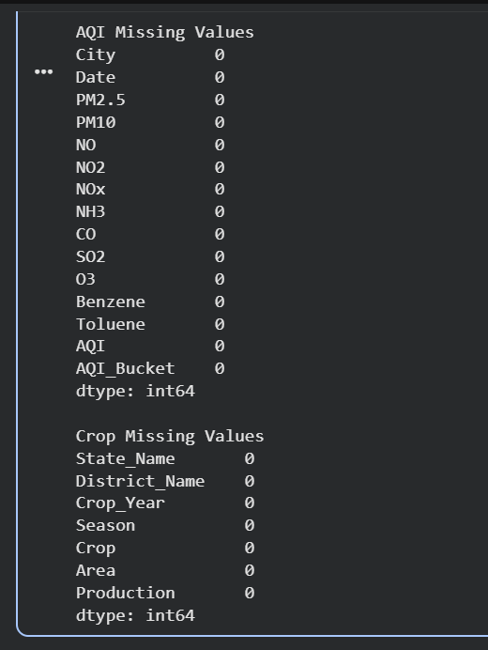
After analysing the datasets, several columns were found to contain missing values. A separate treatment strategy was selected for each column based on the percentage of missing data and the data type.
The Xylene column contained more than 60% missing values and was therefore removed, as imputing such a large proportion of data could introduce bias and reduce reliability.
For numerical columns such as PM2.5, PM10, NO, NO2, NOx, NH3, CO, SO2, O3, Benzene, Toluene, and AQI, missing values were replaced using the median. Median imputation was preferred because air quality data often contains extreme values and skewed distributions.
The AQI_Bucket column is categorical, so missing values were replaced using the mode (most frequent category).
In the crop production dataset, missing values in the Production column were replaced using the median. The remaining records containing missing values were removed because they represented only a very small fraction of the dataset.
Result:
After applying the selected treatment strategies, all missing values were successfully removed from both datasets. The datasets are now complete and suitable for further analysis.

TASK: 3:
To ensure reliable analysis and future dataset integration, duplicate records and naming inconsistencies were investigated.
The AQI dataset contained no duplicate records. The crop production dataset contained 9,717 duplicate records, which were removed. This reduced the dataset size from 255,808 records to 246,091 records.
State names in the crop production dataset were standardized by removing leading/trailing spaces and applying a consistent title-case format. The list of unique states was examined to identify alternative spellings or outdated names. No major inconsistencies such as "Orissa/Odisha" or "Uttaranchal/Uttarakhand" were found.
Inconsistencies Found
- 9,717 duplicate records were present in the crop production dataset.
- Minor formatting inconsistencies in state names were addressed using string standardization techniques.
- The AQI dataset does not contain a State column, which may create challenges during dataset merging and will require additional preprocessing in later tasks.
Code:
aqi_before = len(aqi)
crop_before = len(crop)
print("AQI Records Before:", aqi_before)
print("Crop Records Before:", crop_before)
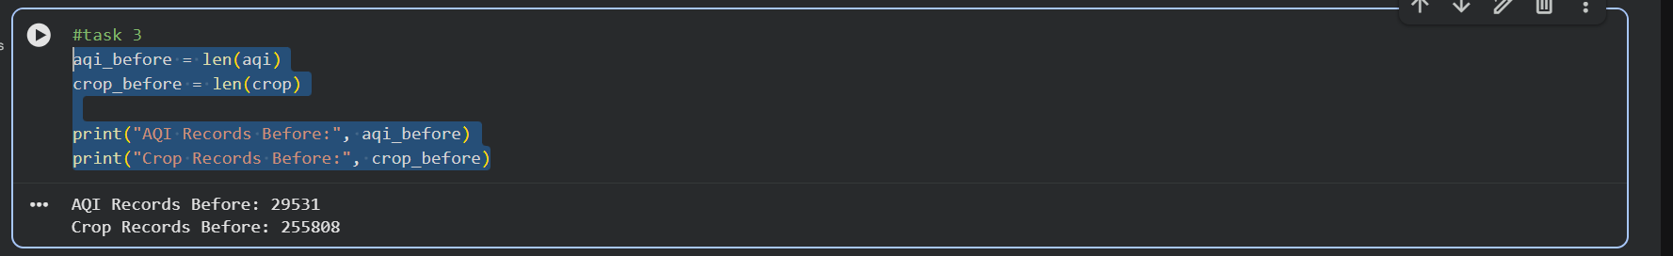
aqi.drop_duplicates(inplace=True)
crop.drop_duplicates(inplace=True)

aqi_after = len(aqi)
crop_after = len(crop)

print("AQI Records After:", aqi_after)
print("Crop Records After:", crop_after)
print("AQI Duplicates Removed:", aqi_before - aqi_after)
print("Crop Duplicates Removed:", crop_before - crop_after)
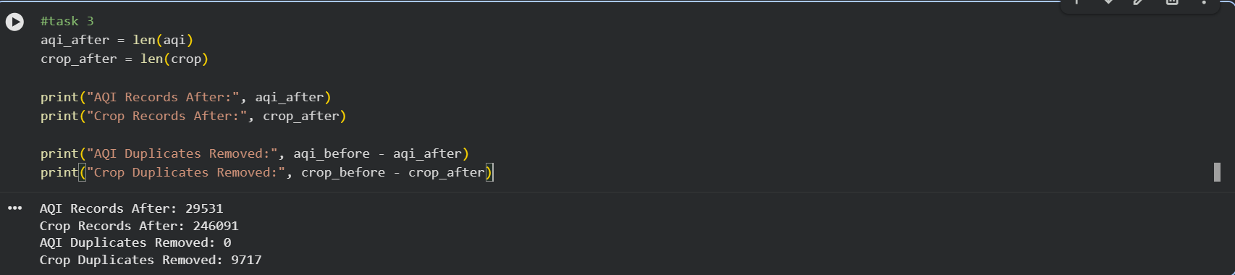
crop['State_Name'] = (
crop['State_Name']
.str.strip()
.str.title()
)

print(sorted(crop['State_Name'].unique()))
Result
Duplicate records were successfully removed, and state names were standardized. The datasets are now cleaner and more suitable for analysis and future merging operations.

Task 4
Code:
plt.figure(figsize=(10,5))
sns.histplot(aqi['AQI'], bins=30, kde=True)
plt.title("Distribution of AQI Values Across Indian Cities")
plt.xlabel("AQI")
plt.ylabel("Frequency")
plt.show()
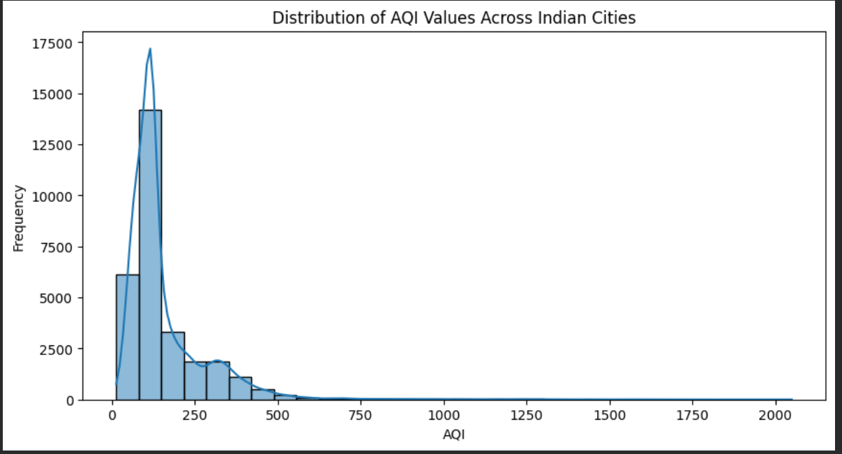

plt.figure(figsize=(10,4))
sns.boxplot(x=aqi['AQI'])
plt.title("Boxplot of AQI Values")
plt.show()
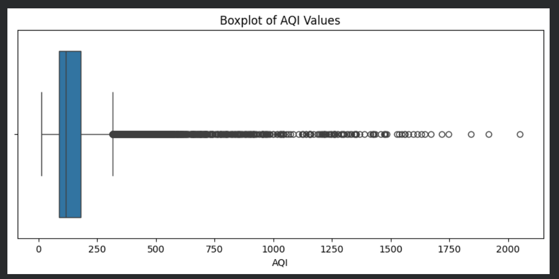

print("Mean AQI:", round(aqi['AQI'].mean(),2))
print("Median AQI:", round(aqi['AQI'].median(),2))

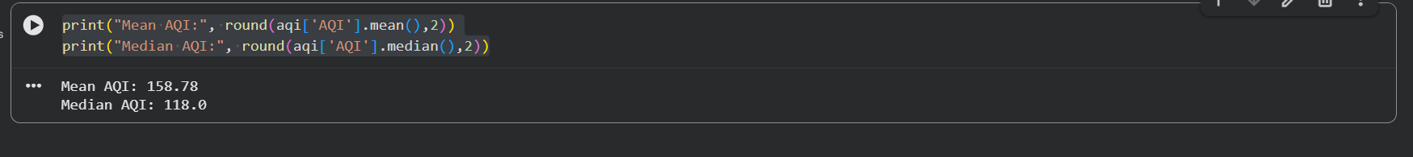
Result:
To understand where most cities lie on the AQI scale and whether extreme values affect the average AQI, two visualizations were selected.
A histogram was used to examine the overall distribution of AQI values and identify where the majority of observations are concentrated.
A boxplot was used to identify extreme values and potential outliers that may influence summary statistics such as the mean.
Using both plots provides a more complete understanding of the data distribution than either plot alone.

Task 5
Code:
Q1 = aqi['AQI'].quantile(0.25)
Q3 = aqi['AQI'].quantile(0.75)
IQR = Q3 - Q1
lower_bound = Q1 - 1.5 * IQR
upper_bound = Q3 + 1.5 * IQR
print("Q1:", Q1)
print("Q3:", Q3)
print("IQR:", IQR)

print("Lower Bound:", lower_bound)
print("Upper Bound:", upper_bound)
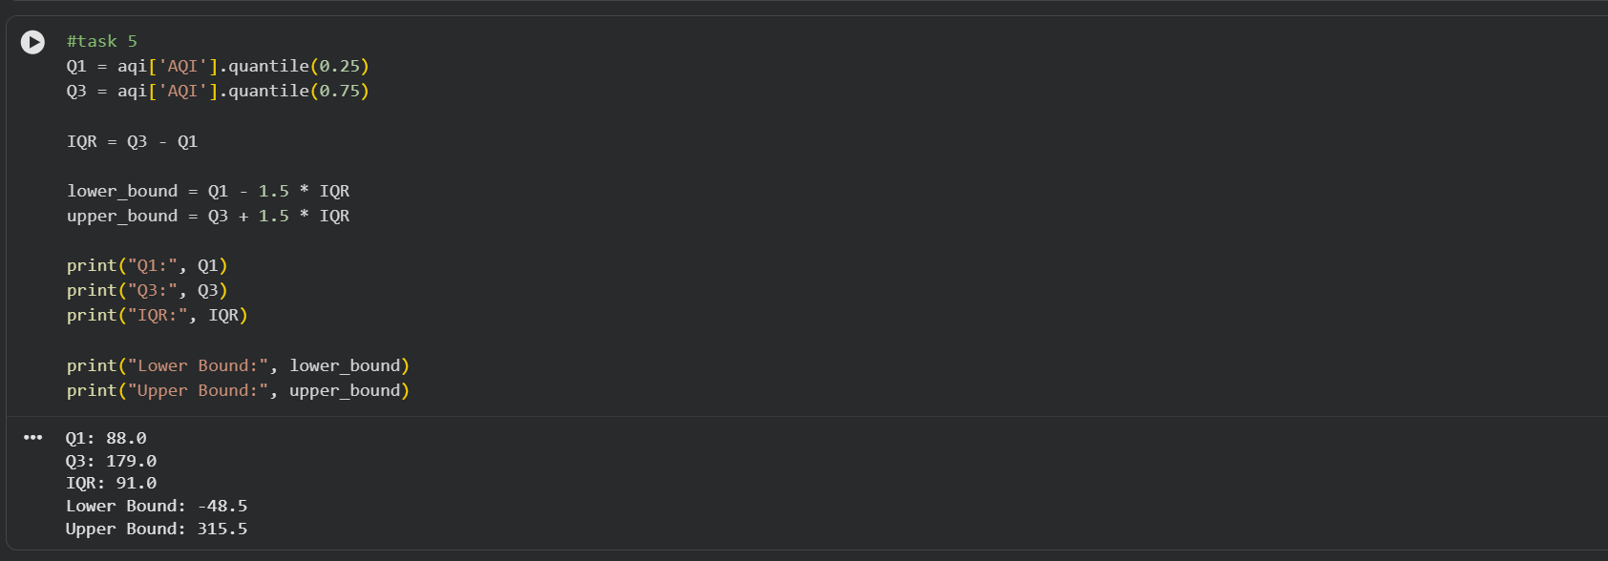
#counting the outliers
outliers = aqi[
(aqi['AQI'] < lower_bound) |
(aqi['AQI'] > upper_bound)
]
print("Number of Outliers:", len(outliers))
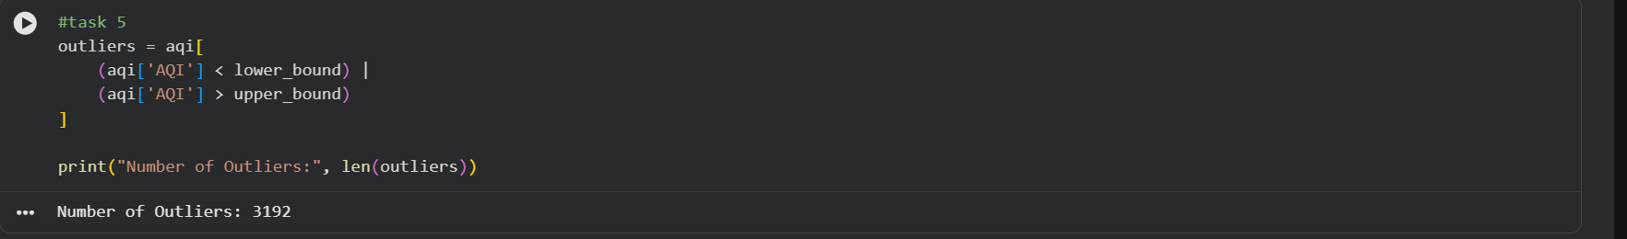
# Save Original AQI
aqi_before = aqi.copy()
# Treat Outliers (Capping)
aqi['AQI'] = aqi['AQI'].clip(
lower=lower_bound,
upper=upper_bound
)
# Compare Before and After
# Before Boxplot
plt.figure(figsize=(10,4))
sns.boxplot(x=aqi_before['AQI'])
plt.title("AQI Before Outlier Treatment")
plt.show()
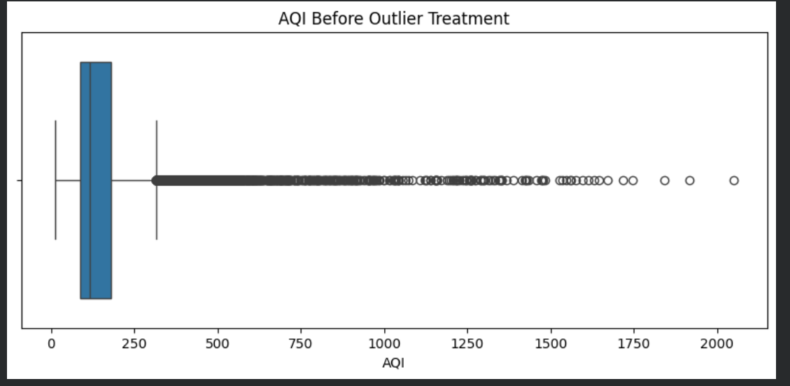
#After Boxplot
plt.figure(figsize=(10,4))
sns.boxplot(x=aqi['AQI'])
plt.title("AQI After Outlier Treatment")
plt.show()

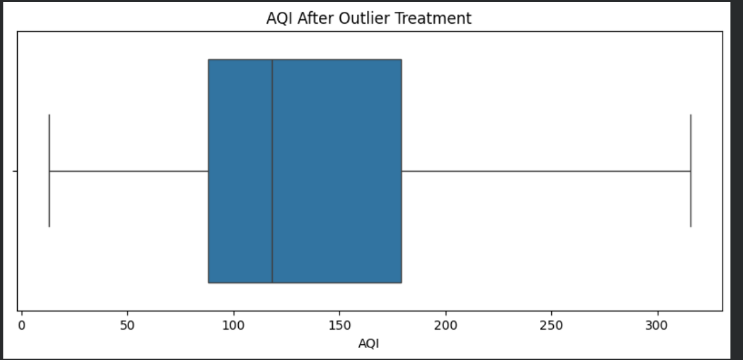
# Verify
new_outliers = aqi[
(aqi['AQI'] < lower_bound) |
(aqi['AQI'] > upper_bound)
]
print("Outliers Remaining:", len(new_outliers))
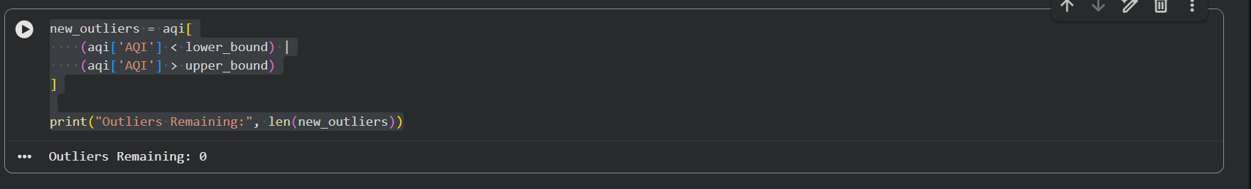
Results
Using the IQR method, 3,192 AQI observations were identified as outliers. These values were greater than the calculated upper bound of 315.5 and had the potential to significantly distort statistical analysis.
After applying capping, all extreme values were brought within the acceptable range while preserving the total number of observations. The boxplot after treatment shows a much more balanced distribution with no remaining outliers.

Conclusion
The IQR method successfully identified 3,192 extreme AQI observations. Instead of removing these records, outlier treatment was performed using capping to preserve valuable information while reducing the influence of unrealistic values. The comparison between the before and after boxplots demonstrates that the treatment effectively eliminated extreme values without reducing the dataset size. As a result, the AQI data is now more suitable for statistical analysis and machine learning applications.

LAB-2

Task-6
Step1: Convert Date Column
aqi['Date'] = pd.to_datetime(aqi['Date'])

Step2: Extract Year
aqi['Year'] = aqi['Date'].dt.year
print(aqi[['Date','Year']].head())
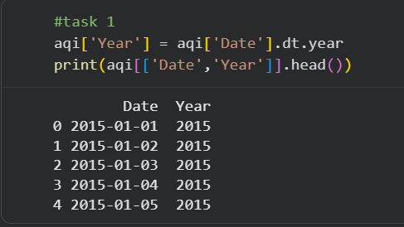

Step 3: Calculate Average AQI by Year
yearly_aqi = aqi.groupby('Year')['AQI'].mean()
print(yearly_aqi)

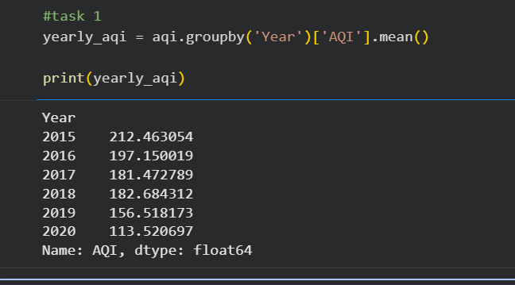

Step 4: Create Trend Plot
import matplotlib.pyplot as plt
plt.figure(figsize=(10,5))
yearly_aqi.plot(marker='o')
plt.title("Average AQI Trend Over Years")
plt.xlabel("Year")
plt.ylabel("Average AQI")
plt.grid(True)
plt.show()
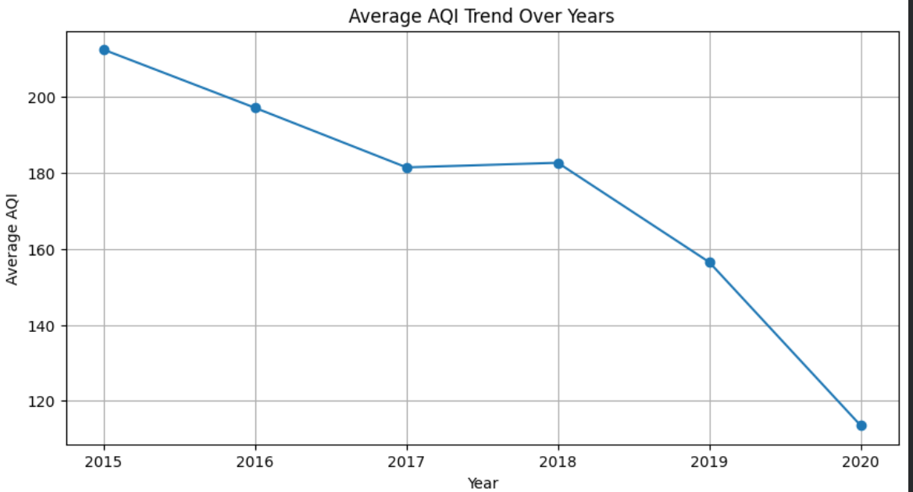

Step 5: Find Most and Least Polluted Years
most_polluted_year = yearly_aqi.idxmax()
least_polluted_year = yearly_aqi.idxmin()
print("Most Polluted Year:", most_polluted_year)
print("AQI:", yearly_aqi.max())
print()
print("Least Polluted Year:", least_polluted_year)
print("AQI:", yearly_aqi.min())
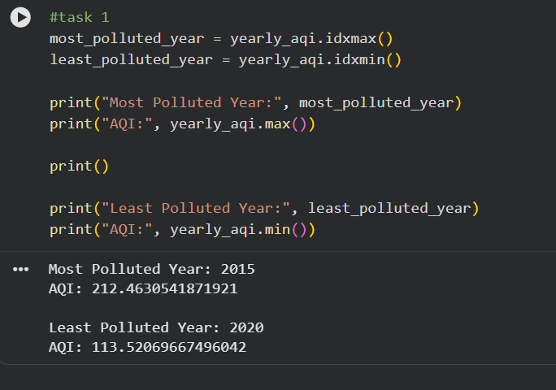

Observation
The average AQI decreased from 212.46 in 2015 to 113.52 in 2020, indicating a significant improvement in air quality over the observed period.
Although AQI generally decreased over time, a slight increase was observed between 2017 and 2018. However, the overall trend remains downward, suggesting long-term improvement in air quality.

Journalist Response
Response to the Journalist
Based on the available data, air quality appears to have improved between 2015 and 2020. The average AQI steadily declined from about 212 in 2015 to around 114 in 2020. Although there was a small increase between 2017 and 2018, the overall trend shows lower pollution levels over time. The most polluted year in the dataset was 2015, while 2020 recorded the lowest average AQI. These findings suggest that air quality conditions improved during the study period, although additional factors and more recent data would be needed to determine the exact reasons for this improvement.
Conclusion
The yearly AQI trend indicates a gradual improvement in air quality from 2015 to 2020. The line chart clearly shows a decline in average AQI values over time, with the highest pollution levels recorded in 2015 and the lowest in 2020. While the trend suggests improving air quality, further investigation would be required to determine whether policy interventions, technological improvements, weather conditions, or other factors contributed to the observed changes.

Task 7
Code:
aqi['Month'] = aqi['Date'].dt.month
monthly_aqi = aqi.groupby('Month')['AQI'].mean()
print(monthly_aqi)

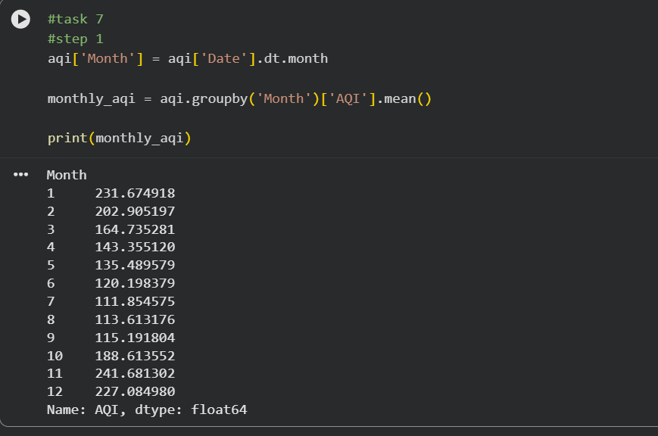

plt.figure(figsize=(10,5))
monthly_aqi.plot(marker='o')
plt.title("Average AQI by Month")
plt.xlabel("Month")
plt.ylabel("Average AQI")
plt.grid(True)
plt.show()
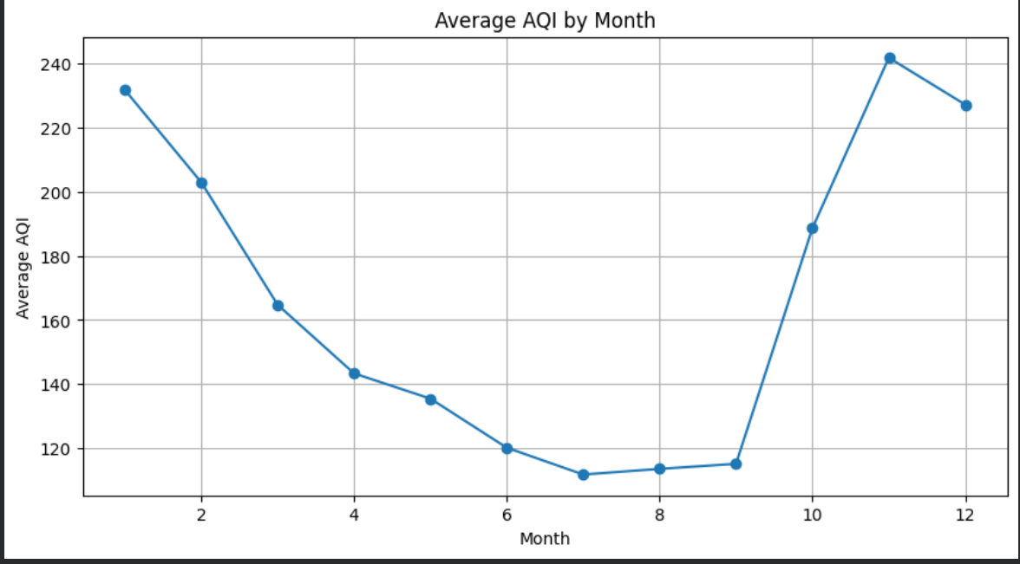

Observation:
The average AQI is lowest during the monsoon months (June to September), reaching its minimum value in July. This suggests that rainfall and atmospheric conditions during the monsoon help reduce air pollution levels.
AQI increases sharply during October, November, and December, with November recording the highest average AQI of 241.68. This indicates a strong seasonal pattern in air pollution levels.
Response to the NGO
The analysis supports the NGO's claim that air quality tends to worsen during the October–December period. Average AQI rises sharply beginning in October and reaches its peak in November before remaining high in December. In contrast, AQI values are considerably lower during the monsoon months from June to September. While the observed pattern is consistent with the possibility of crop residue burning contributing to pollution during the harvest season, this dataset alone cannot prove the exact cause. Other factors such as weather conditions, temperature inversions, industrial emissions, and increased winter pollution may also contribute to the observed increase in AQI.
Conclusion
The monthly AQI analysis reveals a clear seasonal pattern. Air quality is generally better during the monsoon months and significantly worse during late autumn and early winter. The highest pollution levels occur during October–December, particularly in November. These findings support the observation that pollution tends to increase during the harvest season; however, the data does not establish a direct causal relationship between crop residue burning and higher AQI levels.
Task 8
Code:
import seaborn as sns
import matplotlib.pyplot as plt
corr = crop[['Area','Production']].corr()
plt.figure(figsize=(6,4))
sns.heatmap(corr, annot=True, cmap='Blues')
plt.title("Correlation Matrix of Crop Dataset")
plt.show()
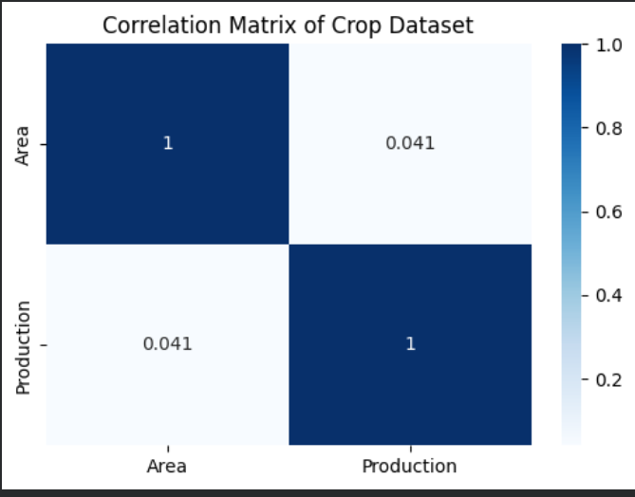

Observation
The correlation between cultivated area and crop production is 0.041, indicating a very weak positive relationship. This suggests that larger agricultural areas do not necessarily result in proportionally higher crop production.
A direct relationship between AQI and crop production could not be analysed because the AQI dataset (2015–2020) and crop dataset (1997–2015) did not contain sufficient overlapping state-year observations after preprocessing.
Conclusion
The datasets were transformed to a common state-year structure in preparation for integration. However, due to differences in temporal coverage and limited overlapping observations, a successful merge could not be achieved. Correlation analysis performed on the crop dataset showed only a very weak positive relationship (0.041) between cultivated area and crop production. This indicates that agricultural output is influenced by additional factors beyond land area, such as irrigation, rainfall, soil quality, farming practices, and crop type. The inability to merge the datasets highlights the importance of ensuring compatibility when combining data from different sources.
Task- 9
Briefing for the State Environment Minister
Madam Minister,
Our analysis of air quality data indicates that average AQI levels improved between 2015 and 2020, declining from approximately 212 to 114. This suggests that overall air quality conditions became better during the study period, although the exact causes cannot be determined from the available data.
A strong seasonal pattern was also observed. Pollution levels rise sharply during October, November, and December, with November recording the highest average AQI. This period may require additional monitoring and targeted interventions because poor air quality appears consistently during late autumn and early winter.
Analysis of the agricultural dataset showed that cultivated area alone has only a weak relationship with crop production. This suggests that factors such as irrigation, rainfall, soil quality, and farming practices play an important role in determining agricultural output.
Based on these findings, increased pollution-control measures should be considered during the October–December period. However, it is important to note that the available datasets do not provide enough overlapping information to prove whether air pollution directly affects crop production. Further integrated data collection would be required before making causal conclusions.

